Name: ________________________________________ Due Date: _________________________

Visca AP Calculus AB – Final Review Weekly #3 (CW) ***DUE: 2/26/18***

2015 section II, #3 – ***NO graphing calculator required***

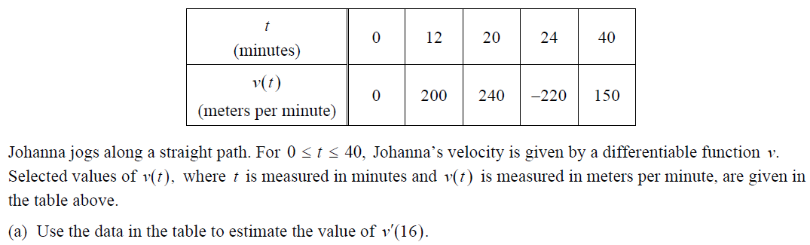

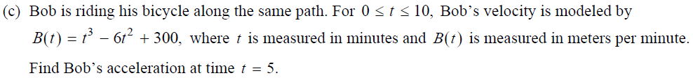

You need equation for acceleration, and appropriate units label.

2015 section II, #6 – ***YES graphing calculator allowed!!!***

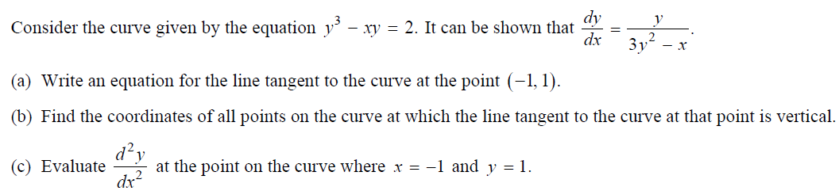

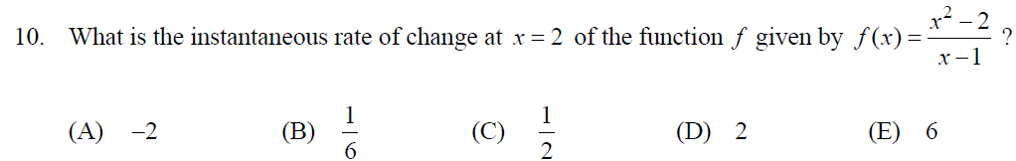1998 section I, #10 – ***NO graphing calculator allowed!!!***

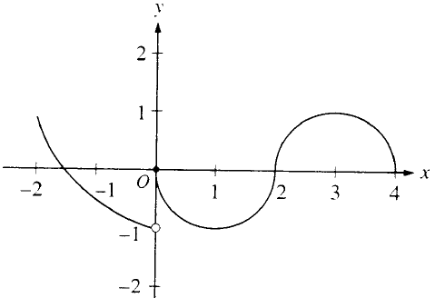1998 section I, #13 – ***NO graphing calculator allowed!!!***

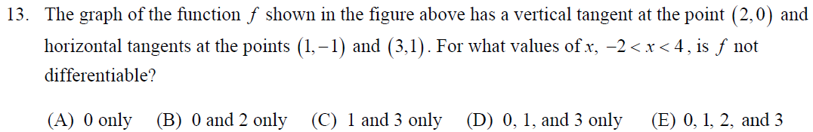

1998 section I, #18 – ***NO graphing calculator allowed!!!***

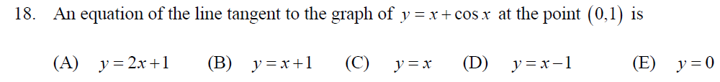

1998 section I, #80 – ***YES graphing calculator required***

